# How to make a video game

## Lec 2- Programming

using UnityEngine;

public class PlayerMovement : MonoBehaviour{

public Rigidbody rb;

void Start(){  
 Debug.Log(“Hello world!”);

// rb.useGravity = false;

}

void Update(){ //called once per frame

}

void FixedUpdate(){ // Better if we do physics stuff inside this method

// x y z

rb.AddForce(0, 0, 2000 * Time.deltaTime);

//amount of time since last frame

}

}

## Lec 3- Movement

To fix rotation of object when collide whit ground:

1. Player – RigidBody – Constraints – freeze Rotation – x

OR

1. New Physics Material – Dynamic and Static friction: 0 –> Apply to Ground

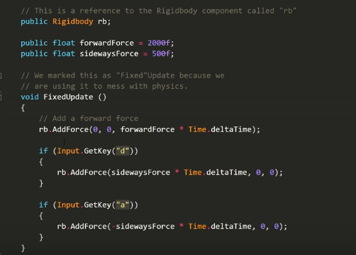

## Lec 4- Camera Follow

1. Making Player object parent of camera

OR

1. Camera object script:

using UnityEngine;

public class FollowPlayer : MonoBehaviour {

public Transform player; // A variable that stores a reference to our Player

public Vector3 offset; // A variable that allows us to offset the position (x, y, z)

// Update is called once per frame

void Update () {

// Set our position to the players position and offset it

transform.position = player.position + offset;

}

}

## Lec 5- Collision Behavior

using UnityEngine;

public class PlayerCollision : MonoBehaviour {

public PlayerMovement movement; // A reference to our PlayerMovement script

// This function runs when we hit another object.

// We get information about the collision and call it "collisionInfo".

void OnCollisionEnter (Collision collisionInfo)

{

// We check if the object we collided with has a tag called "Obstacle".

if (collisionInfo.collider.tag == "Obstacle")

{

movement.enabled = false; // Disable the players movement.

}

}

}

## Lec 6- Gameplay

Create Prefab out of Obstacle -> Create more Obstacle objects out of Prefab

Switch to isometric view

Create ‘Environment’ layer for Ground object and hide it so that it doesn’t get selected in the view

Edit-Snap Settings -> Configure grid parameters -> Press ctrl while moving object to move in grid

Duplicate Obstacles (Ctrl+D)

Change Player movement script:

if (Input.GetKey("d")) // If the player is pressing the "d" key

{

// Add a force to the right

rb.AddForce(sidewaysForce * Time.deltaTime, 0, 0, ForceMode.VelocityChange); // The fourth parameter automatically compensates for the additional force required when momentum increases by forward force

}

if (Input.GetKey("a")) // If the player is pressing the "a" key

{

// Add a force to the left

rb.AddForce(-sidewaysForce * Time.deltaTime, 0, 0, ForceMode.VelocityChange);

}

Add some Drag (1) (Air resistance) in the Player-RigidBody to make controls better. Will stop much faster and will attain a top speed?

Add fog from Windows-Lighting view-Scene

Ctrl+P – to play

F – focus on object

Shift+Space – maximize game view

## Lec 7- Score and UI